*Report*



**제 목 : Term Project**

**과 목 명 : DataBase**

**담당교수 : 김 철 연 교수님**

**소 속 : 소프트웨어 설계 경영학과**

**학 번 : 201133216**

**이 름 : 정유석**

**제 출 일 : 2014 - 12 - 22**

EMB0000084450af

**< CATEGORY >**

1. Introduction

- Purpose

- Area

- Number of Record & Relation

2. UI & CODE

- Explain of my code

3. Some Screen Shot

**1 . INTRODUCE**

* **Purpose :**

I need area discharge of Electronic Power Station (EPS) in Korea, because I want to show the pollution near the EPS.

So, I find recent discharge of Korea East-West Power Plant.

And, I show you the chart of pollution and record.

* **Area :**

Korea East-West Power Plant.

Dangjin – Ulsan – Donghae – Ilsan - Honam

* **Number of Record & Relation :**

Number of Record is 276.

Number of Relation is 1.

**2 . UI & CODE**

* **Explain :**

I use 1 Frame and insert to Image of Building of EPS.

And Insert year button and text area and graph area.

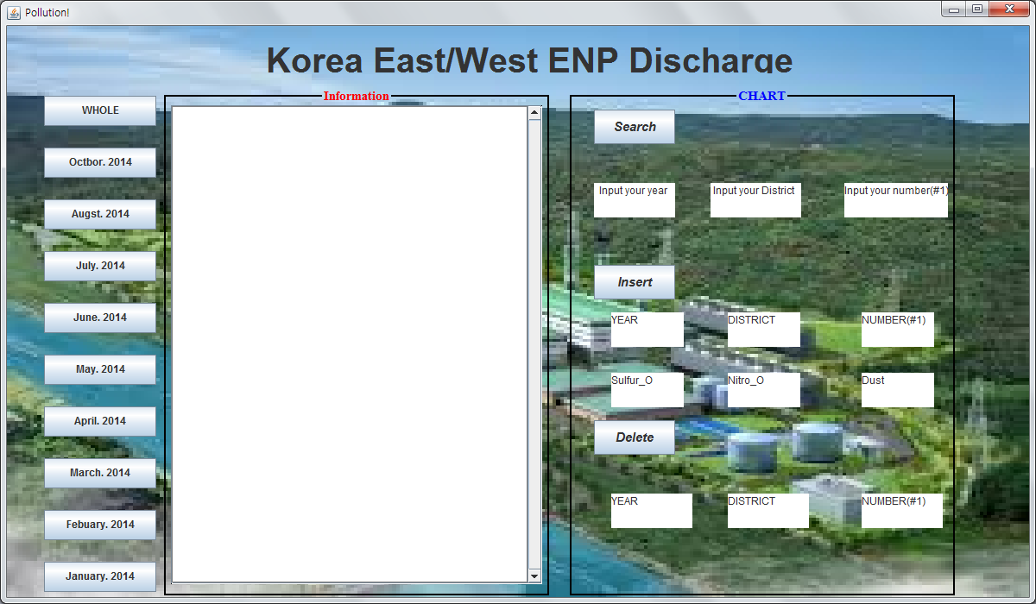

This is first screen of my project.

If you click the year button then, show the bar graph of discharge in area and some text of information of discharge each area.

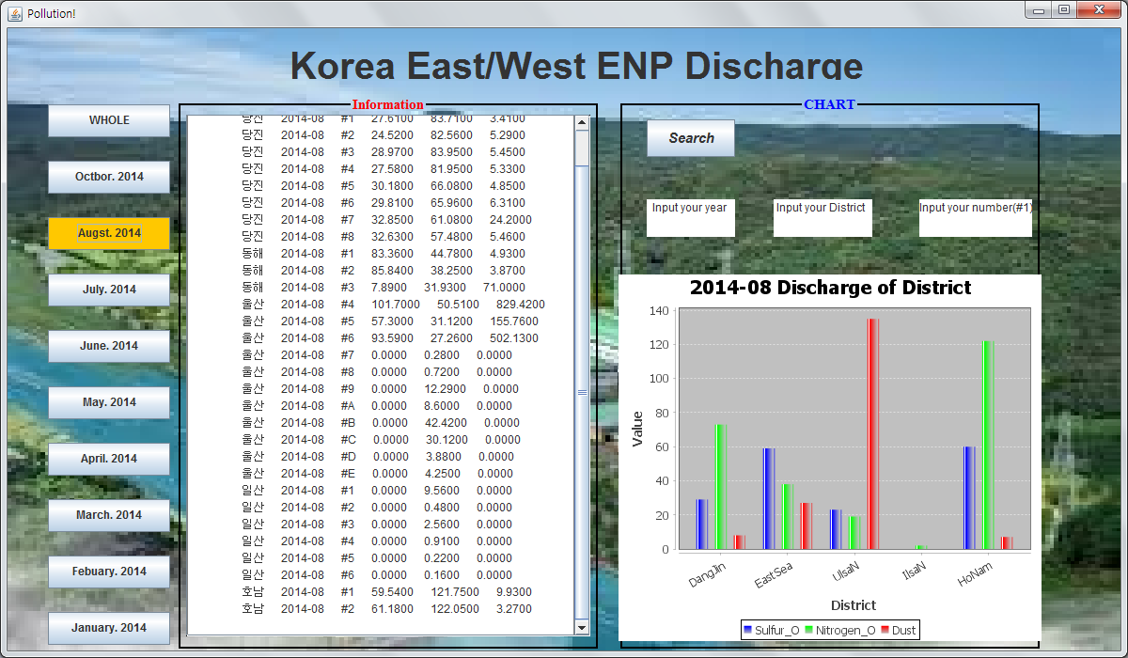

If you click the WHOLE button in left side, show the average of discharge in year (Dust, Nitrogen_O, Sulfur_O)

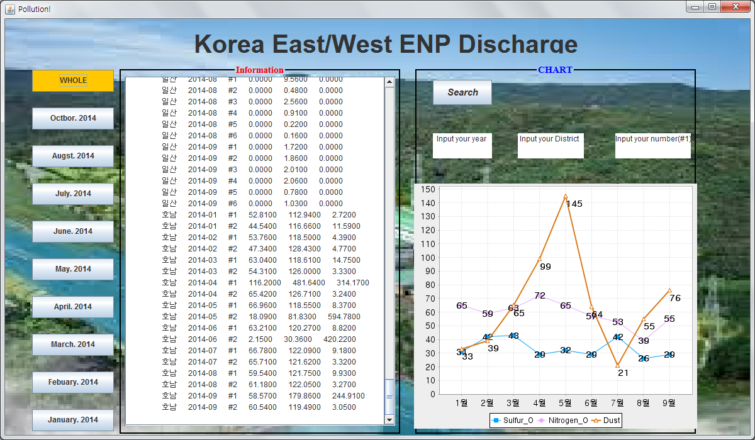

If you fill the Insert or delete text area and click the button, Insert or delete record in database of discharge.

***<Search>*** 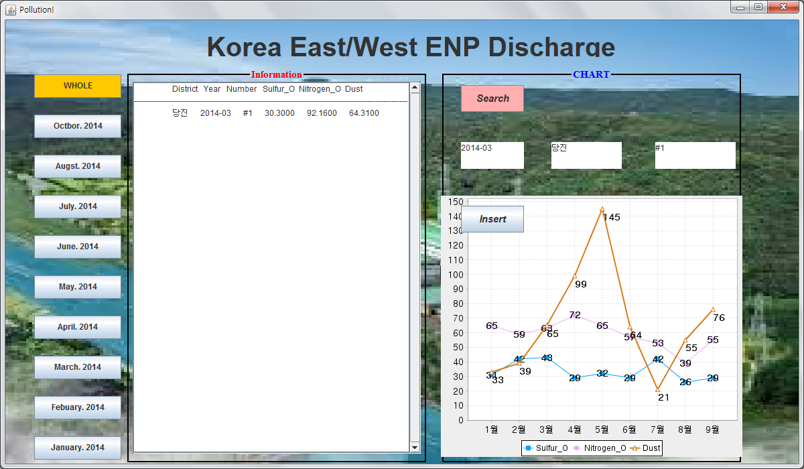

***<Insert>***

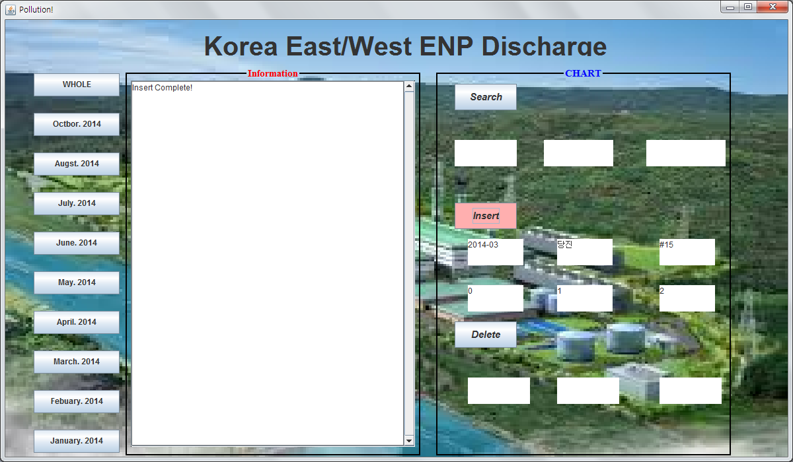

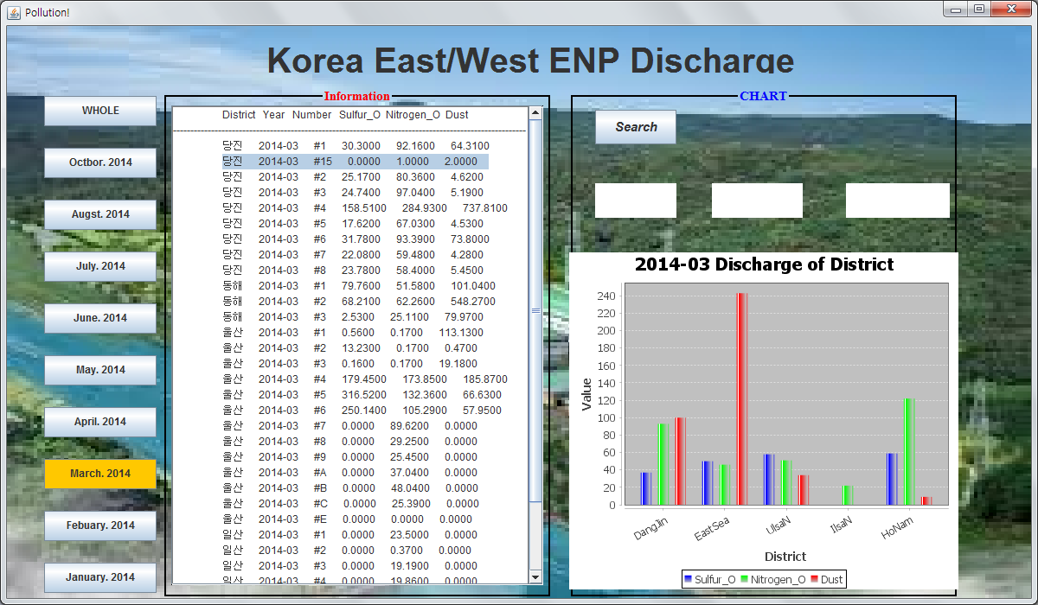

***<Delete>***

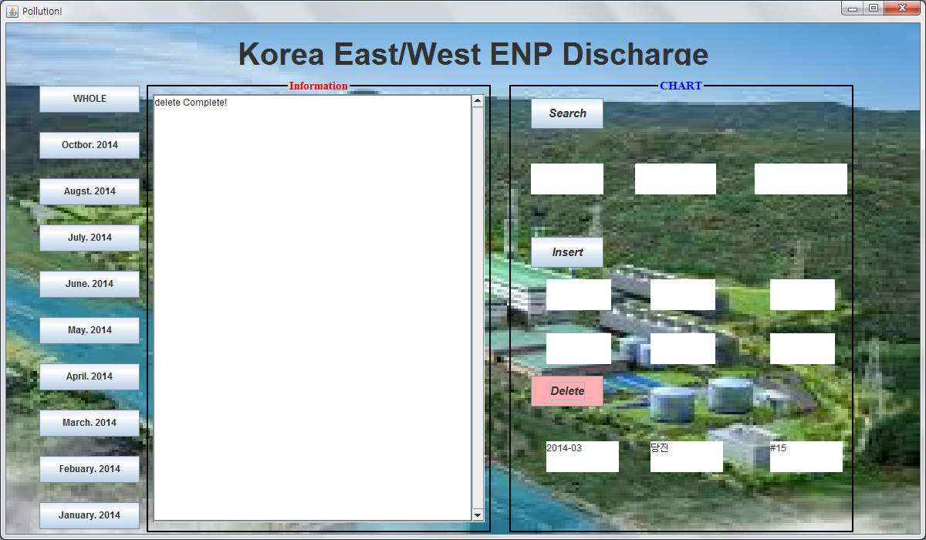

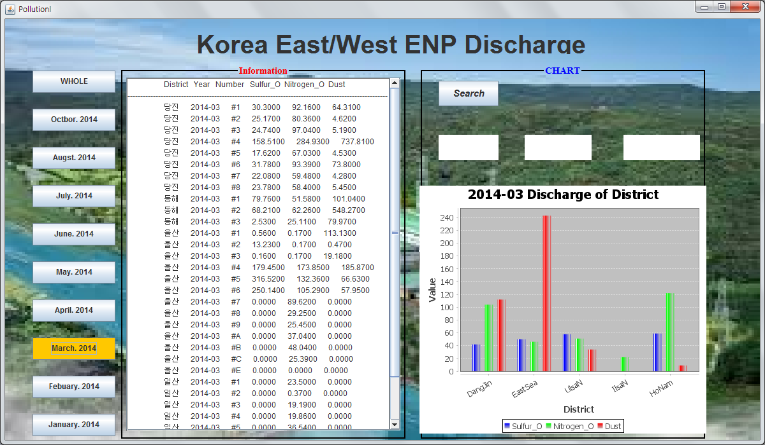

***<CODE>***

* Show the bar-chart of discharge in year. And line-chart of whole

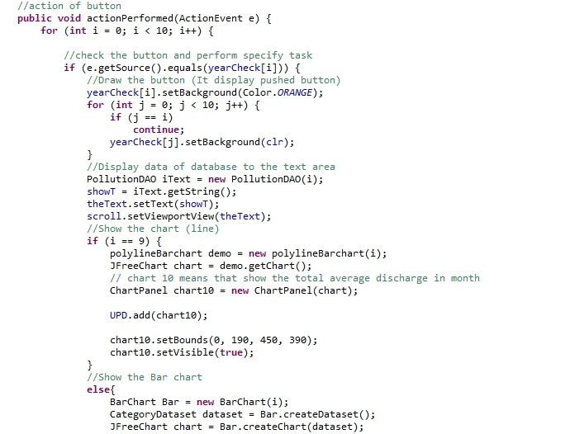

* Connect to Database (Insert)
* 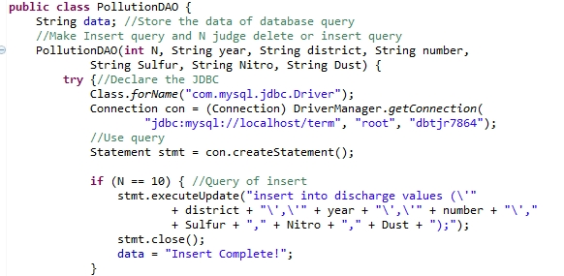
* Receive data and construct line-chart data set.

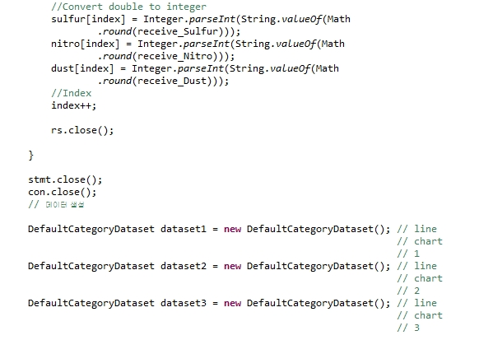

* Receive data from database and show the text of this information

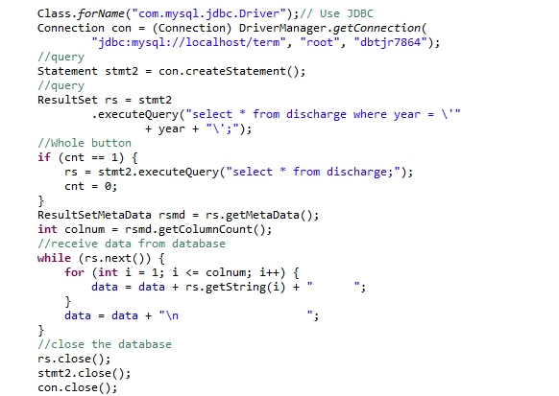

**3 . Some Screen Shot**

* My Class

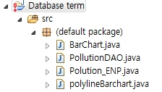

* Original Back Ground image

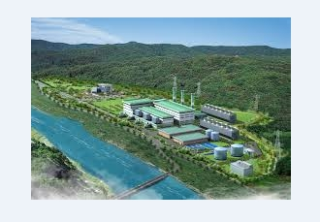

* Bar-chart & Line Chart
* 